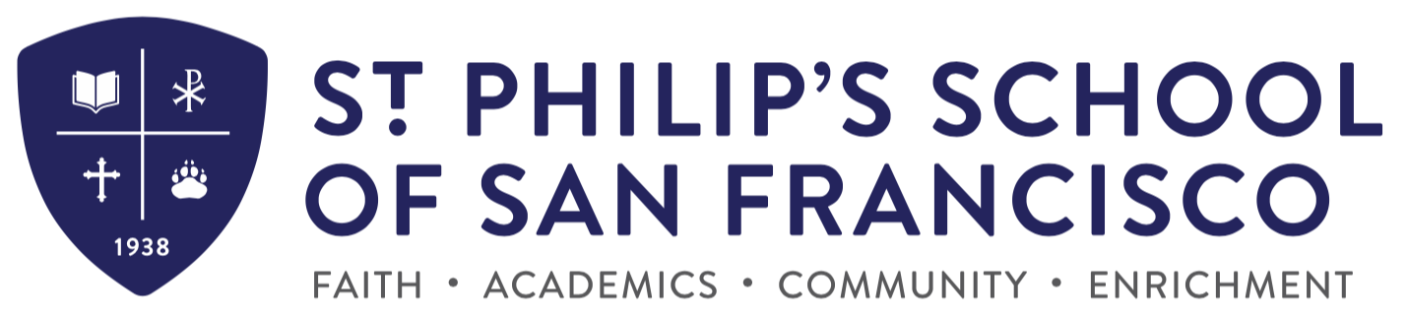

Application Process & Key Dates for Kindergarten (2022-2023)

- Download on the school website. You may also call the school office (415 824 8467) and arrange to pick up an application.

- Completed Application Packets must include:
  - Completed application form
  - Copies of Birth and Baptismal Certificates
  - Current record of all immunizations
  - $75 non-refundable application fee
  - Applications for Kindergarten for the 2022-2023 school year are due Friday, December 10th, 2021
  - Report from your child’s preschool (if child attended)

- You will be notified to schedule an assessment for your child. Assessments will take place in January.

- You will be notified by mail of your child’s acceptance by late January 2022. At this time, you will also receive the enrollment packet which must be submitted within 2 weeks of acceptance to hold placement. The enrollment process requires you to complete the forms and include the non-refundable Enrollment Fee of $550.

